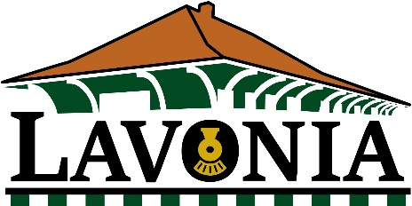

CITY OF LAVONIA
Temporary Street/Public Space
Closure Application and Permit

Application Date:

Event Date:

Applicant Name:

Applicant Contact Info:

Request Date and Location - What type of event will be held? Map Attached?

Start and finish time:

What resources are being requested from the City?

In consideration for the issuance of a Special Event Permit (“Permit”) and to the furthest extent allowed by law, Permittee does hereby agree to indemnify, hold harmless and defend the City of Lavonia (“City”) and each of its elected officials, officers, officials, employees, agents and volunteers from any and all loss, liability, fines, penalties, forfeitures, costs and damages (whether in contract, tort or strict liability, including but not limited to personal injury, death at any time and property damage) incurred by City, Permittee or any other person, and from any and all claims, demands and actions in law or equity (including attorney's fees and litigation expenses), arising or alleged to have arisen directly or indirectly out of the special event. Permittee’s obligations under the preceding sentence shall apply regardless of whether City or any of its elected officials, officers, officials, employees, agents or volunteers are negligent, but shall not apply to any loss, liability, fines, penalties, forfeitures, costs or damages caused solely by the gross negligence, or caused by the willful misconduct, of City or any of its elected officials, officers, officials, employees, agents or volunteers.

Throughout the life of this Agreement, Permittee shall pay for and maintain in full force and effect all insurance as required in Exhibit A, which is incorporated into and is hereby part of this Agreement, or as may be authorized or required in writing by the City Manager or his/her designee at any time and in his/her sole discretion. Permittee shall conduct all defense at his/her/its sole cost. The fact that insurance is obtained by Permittee shall not be deemed to release or diminish the liability of Permittee, including, without limitation, liability assumed under this Agreement. The duty to indemnify shall apply to all claims regardless of whether any insurance policies are applicable. The duty to defend hereunder is wholly independent of and separate from the duty to indemnify and such duty to defend exists regardless of any ultimate liability of Permittee. The policy limits do not act as a limitation upon the amount of defense and/or indemnification to be provided by Permittee. Approval or purchase of any insurance contracts or policies shall in no way relieve from liability nor limit the liability of Permittee, its officials, officers, employees, agents, vendors, concessionaires, invitees or volunteers. City shall be reimbursed for all attorney’s fees and costs incurred by City in enforcing this Agreement. This Agreement shall survive the expiration or revocation of the Permit.

The undersigned acknowledges that he/she (i) has read and fully understands the content of this Indemnification and Hold Harmless Agreement; (ii) is aware that this is a contract between the City and Permittee; (iii) has had the opportunity to consult with his/her attorney, in his/her discretion; (iv) is fully aware of the legal consequences of signing this document; and (v) is the Permittee or his/her/its authorized signatory.

_______________________________________ _______________
Signature Date

